**Assignment Day 11**

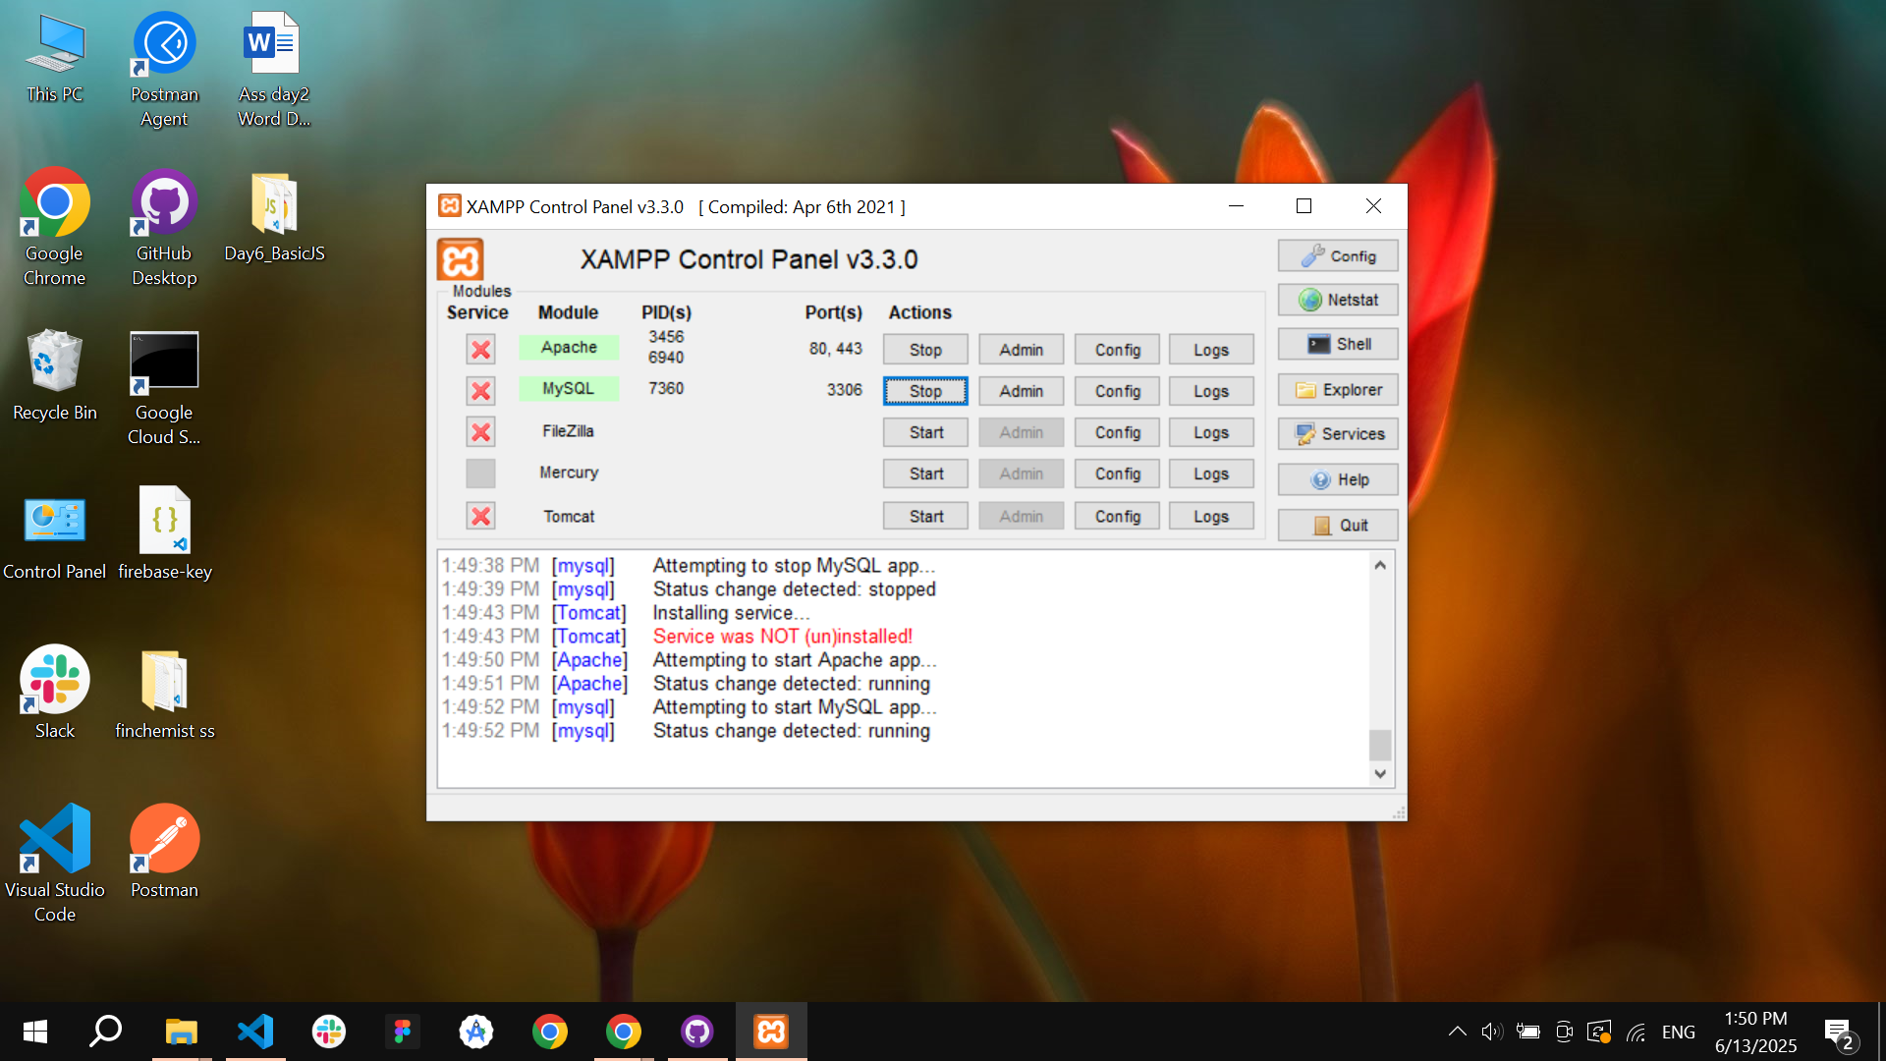

I started and ran Apache and MySQL using the XAMPP Control Panel. I took a screenshot showing both services running successfully, pasted it into a Word document, and uploaded the file to my GitHub repository as part of the submission process.